More than Words and Data

Online Grooming Logs Analysis with Voyant

Nicole Arnt (Student ID# 6611354)

IASC 2P02 Solving Problems through Interactive Arts and Science

Prof. Aaron Mauro

April 12, 2022

**Abstract**

The internet is celebrated as a vast network that connects computers and people all around the world. Unfortunately, this connectivity comes with a price. Cybertip.ca alone processed 4.3 million (Government of Canada, 2021) online sexual child exploitation reports between

2014-2020. This research project examines the hypothesis that the type of high frequency words in online grooming chats with minors reveals a predator’s conversational strategy. Sexual child exploitation has not just become a prevalent issue with the beginning of the internet age. A historical timeline ([Figure1](https://cdn.knightlab.com/libs/timeline3/latest/embed/index.html?source=13PwFNj2K0MsZOgHJLD6iyPa8Sc1cAz_0u-0_VDSp3-c&font=Default&lang=en&initial_zoom=2&height=650)) was created to visually illustrate that this form of child abuse has been part of the societal fabric since “the beginning of time”. The hypothesis was tested by using four chat-log transcripts from the website Perverted- Justice.com. These were visually displayed with Voyant Tools (Sinclair & Rockwell, 2016) and compared. The results show that words of agreement (yea, yes, ok, okay, ya, cool) or words expressing a preference (like, want) are the

most frequently used words in the grooming chat logs with presumed 13/14-year-old teenage girls. This finding suggests that the conversational strategy of a sexual predator is above all to create an environment of constant compliance and agreement for their desires.

**Introduction**

Bethany Nowviskie (2014) uses, in a conference talk she prepared for Digital Humanities 2014, the deep and shallow ends of a swimming pool as a metaphor for time. When we look at both ends of the sexual child exploitation “pool”, we come to realize that this issue is not a new phenomenon. It was prevalent even in Ancient Greece (Westlake, 2020, p.5). [Figure 1](https://cdn.knightlab.com/libs/timeline3/latest/embed/index.html?source=13PwFNj2K0MsZOgHJLD6iyPa8Sc1cAz_0u-0_VDSp3-c&font=Default&lang=en&initial_zoom=2&height=650) shows an outline, predominantly based on Westlake’s (2020) research, of what child exploitation looked like in different historical periods. In general, life from antiquity until now has changed dramatically, but the core issue of sexual child abuse has been a constant companion throughout time ([Figure 1](https://cdn.knightlab.com/libs/timeline3/latest/embed/index.html?source=13PwFNj2K0MsZOgHJLD6iyPa8Sc1cAz_0u-0_VDSp3-c&font=Default&lang=en&initial_zoom=2&height=650)). This research project will focus on challenges that have come with the internet age, and more specifically it will analyze if frequently used words in online grooming chats can reveal a pedophile’s conversational strategy. Chat-log transcripts from Perverted-Justice.com are used as data sets. Perverted-Justice is a not-for-profit organization, which works in conjunction with law enforcement, to convict internet predators. Adult volunteers of this community pose as minors in chat rooms to lure pedophiles. Their efforts have been credited with 623 cyber predators' convictions to date (Perverted-Justice, n.d.). These chats have been transcribed and made available to the public and are used for research purposes (Chatcoder, n.d.). The linguistic properties of the Perverted Justice dataset have been investigated in several studies. Black et al. (2015) use the data for a linguistic analysis of grooming strategies of online child sex offenders. Chiu et al. (2018) create a statistical discourse analysis of self-disclosure and emotion words of online sexual offenders in chats with minors, and Egan et al. (2011) produce a content analysis of the language used by offenders attempting to solicit children for sex. This project wants to add to these discussions.

**Figure 1**

***Historical Timeline of Child Exploitation***

[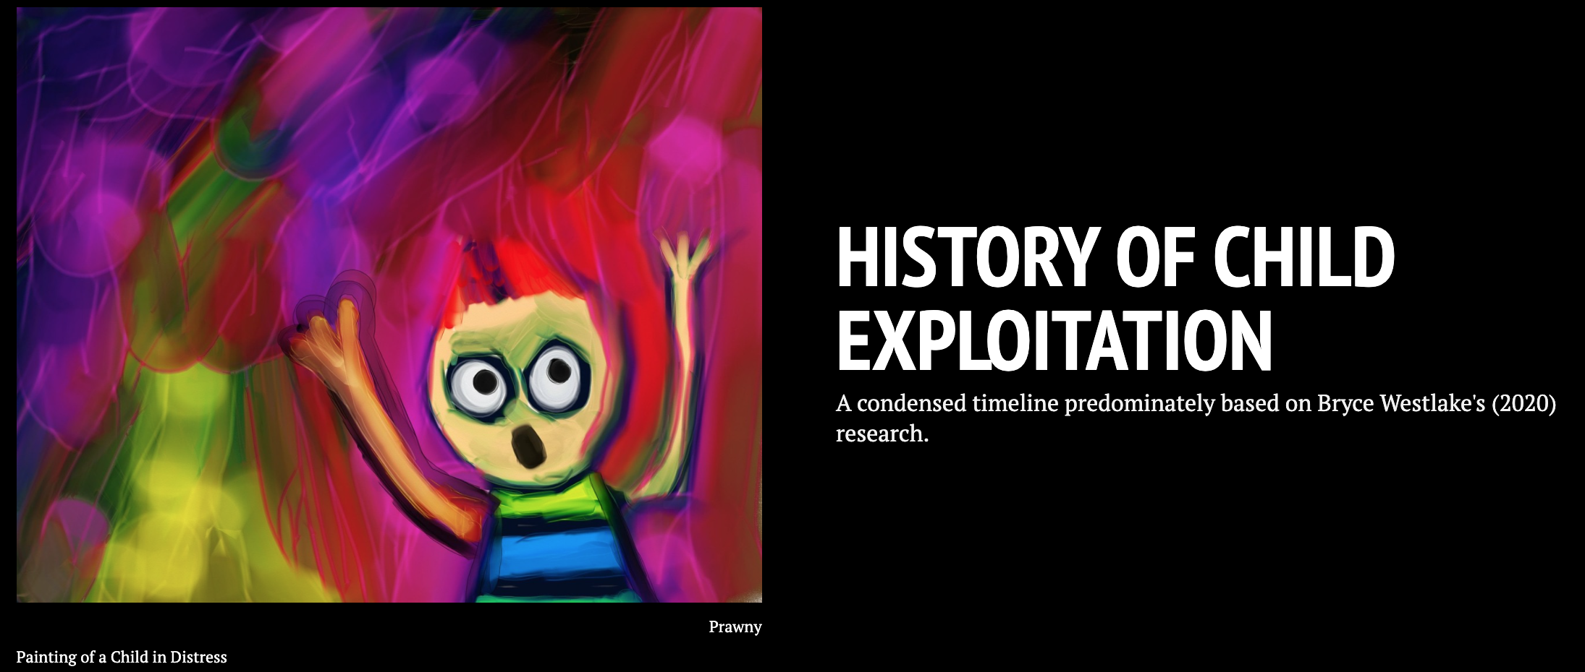](https://cdn.knightlab.com/libs/timeline3/latest/embed/index.html?source=13PwFNj2K0MsZOgHJLD6iyPa8Sc1cAz_0u-0_VDSp3-c&font=Default&lang=en&initial_zoom=2&height=650)

**Methods**

Four chat-log transcripts from the website Perverted-Justice.com were used for this project. Two are from their section “Random Convictions” and two can be found in the category “Most Slimy.” These recorded online conversations show text exchanges between sexual predators from different geographic regions in the USA (Louisiana, Florida, Illinois, and Virginia) and their perceived 13- or 14-year-old female victims. Associates from the not-for-profit organization Perverted-Justice.com posed as minors and worked with law enforcement agencies to convict these individuals with these chat logs. To test the hypothesis that high-frequency words in online grooming chats with underage victims reveal the predators’ conversational strategy, transcripts A, B, C and D have been visually displayed with Voyant Tools (Sinclair & Rockwell, 2016) and compared.

Transcript A (Harvey, 2004) documents a conversation between internet predator Paul Short, age 34, from Chicago, Illinois and what he thought is a 13-year-old girl named Kristen from the same area. The text exchange is lengthy, graphic and extends over four days. The online conversation took place on Yahoo IM. Paul Short had the username: fleet_captain_jaime_wolfe and “Kristen” was logged in as sadlilgrrl.

Transcript B (Retired Contributor, 2016a) shows the messages between Barry Daniel Darish, age 36, from Miramar Beach, Florida, and Erica, who he thought was a 14-year-old girl. The online conversations occurred over several days on Meetme.com and Snapchat Text Messaging. Barry called himself Adam in the chats and had the username: Nice Guy. He intended to pick up Erica and take her back to his house on the beach for a weekend of sex.

In Transcript C (Retired Contributor, 2016b) Justin Earl Oliver, 28, from Baton Rouge, Louisiana who goes by the username: louisianamaster1983 tried to solicit Sarah. He assumed she was a 13-year-old girl, and his goal was to make her submissive to the point where he was the master, and she did everything he told her to do. This would not only include sexual interactions but also everyday life decisions like what to wear or what to eat. Their message exchange took place over several days on Yahoo IM.

Transcript D (De Camp, 2006) transcribes several chats between Joe, 28, from Alexandria, Virginia and a presumed 14-year-old girl named Erin. Joe expressed extremely graphic sexual requests that included among other things Erin’s neighbour’s dog. He intended to live out his fantasies when Erin’s mom was on vacation. Their conversation took place on Yahoo IM and his username was: vamale_692005.

All four scripts were imported into Voyant Tools (Sinclair & Rockwell, 2016) to analyze the texts and show the results in a visual format. Transcripts A-D were edited in the open-source tool by adding unique stop words that would eliminate the texts’ timestamps and the names of the dialogue partners. For this project, it did not matter who said what, but rather the focus was on word choices by either party. The data was displayed as a cirrus (word cloud) and a trends graph to digitally organize the content of the transcripts and provide additional insight into the communication logs.

**Results**

Transcript A (Perverted Justice: Most Slimy Category) consists of 12,931 total words. The five most frequent terms that occur in this corpus are: *master* used 489 times, *good* used 258 times, *yes* used 206 times, *want* used 124 times and *know* used 106 times. Voyant created a word cloud with 50 other high-frequency words (Table 1). The accompanying trends graph (Table 2) illustrates in which segment of the document these terms occur and their relative frequency. It is easily observed that the word master does not only appear with disproportionally high frequency in this online message exchange but also that there seems to be a shift in the conversation between segments 5 and 6. By clicking on the data points in the graph, Voyant highlights in a reader win-dow wherein the text these terms are used and puts them into context. In our case, the predator established a master-slave connection, which set the tone and established the type of relationship from here on in.

**Table 1 Table 2**

***Word Cloud Transcript A Trends Graph Transcript A***

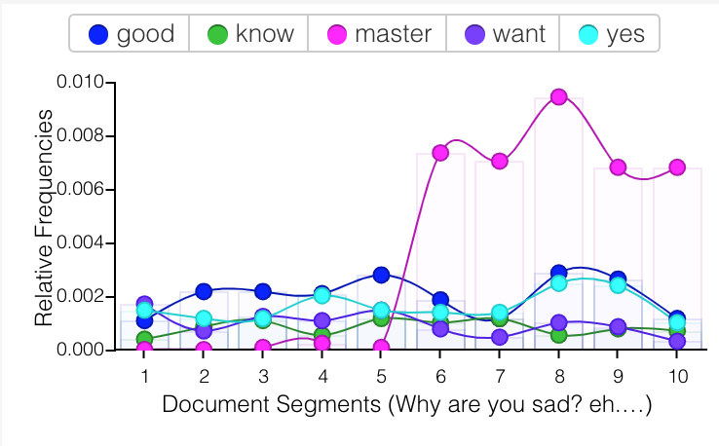

*Note.* Trends Graph of the top five words used most frequently in transcript A created in Voyant Tools.

*Note.* Word Cloud (Cirrus) of 55 high

frequency words from transcript A

created in Voyant Tools.

Transcript B (Perverted Justice: Random Convictions Category), in comparison, contains only 3,230 total words. The word cloud (Table 3) shows that the five most frequent terms in this corpus are: I’m (47), lol (46), like (31), ok (25) and yea (23). The accompanying trends graph (Table 4) illustrates that in one part of the conversation, between the 6th and 7th document segment, the word lol is used more frequently than any other word. The texting acronym “lol” has been used by both parties and seem to indicate different emotions beyond the emphasis of a funny situation.

**Table 3 Table 4**

***Word Cloud Transcript B Trends Graph Transcript B***

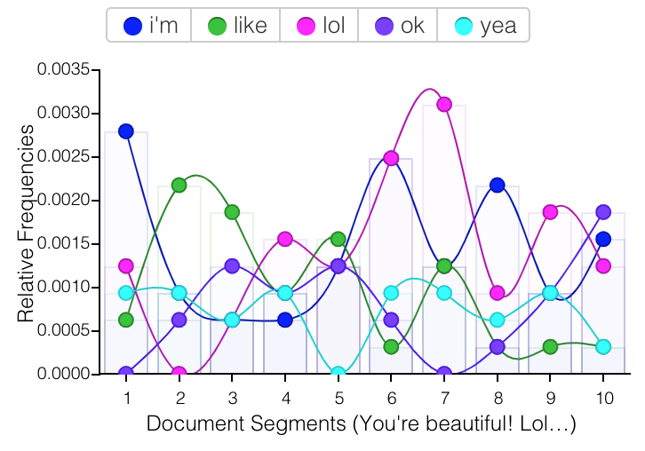

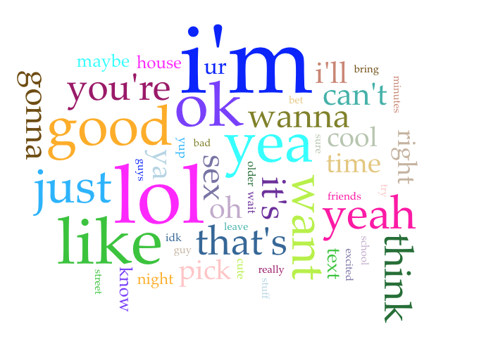

*Note.* Trends Graph of the top five words used most frequently in transcript B created in Voyant Tools.

*Note.* Word Cloud (Cirrus) of 55 high

frequency words from transcript B.

Transcript C (Perverted Justice: Random Convictions Category) has a corpus with 10,492 words. The five words used most frequently (Table 5) are: *ok* (71), *ur* (58), *lol*(56), *like* (49) and *ya* (43). The accompanying trends graph (Table 6) highlights that the word *ok* is dominantly used throughout the whole chat and does not show unusual spikes just in certain segments.

**Table 5 Table 6**

***Word Cloud Transcript C Trends Graph Transcript C***

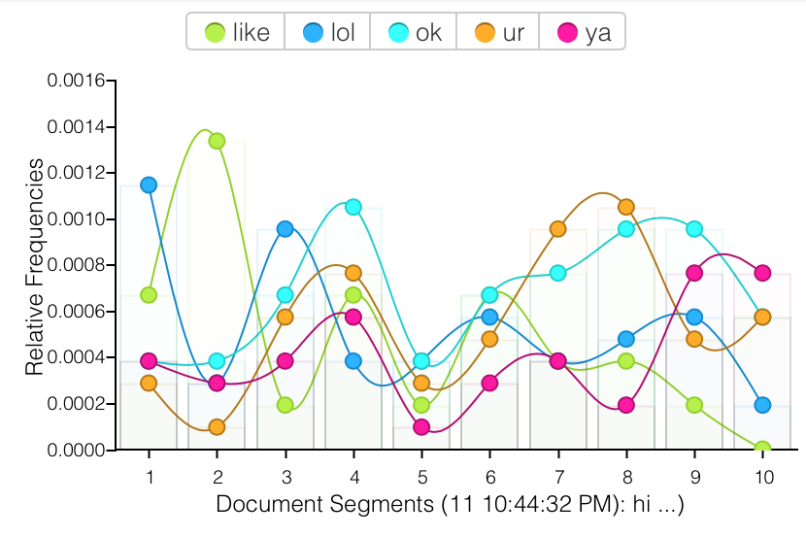

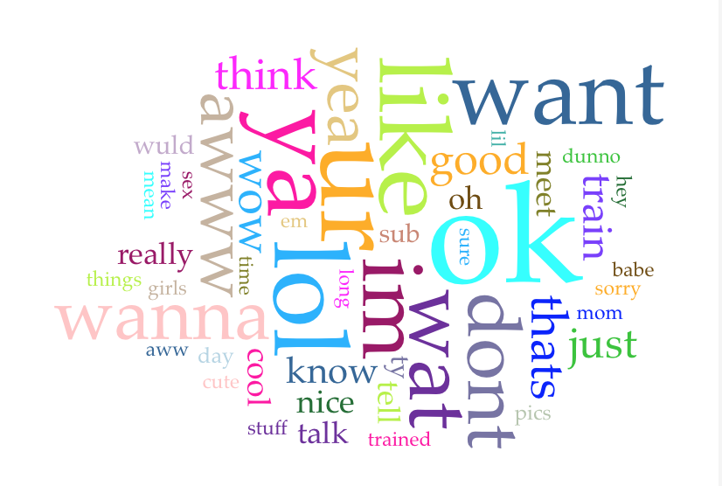

*Note.* Trends Graph of the top five words used most frequently in transcript C created in Voyant Tools.

*Note.* Word Cloud (Cirrus) of 55 high

frequency words from transcript C.

Transcript D (Perverted Justice: Most Slimy Category) has 21.052 words, and the five most frequent words (Table 7) are: *yea* (180), *okay* (149), *like* (104), *ok* (79) and *cool* (78). The trends graph (Table 8) shows two significant spikes of the words *yea* and *ok* in the seventh and tenth document segment. Clicking on these data points in Voyant reveals that they were used in the context of the predator requesting and suggesting sexual preferences and planning to meet-up.

**Table 7 Table 8**

***Word Cloud Transcript D Trends Graph Transcript D***

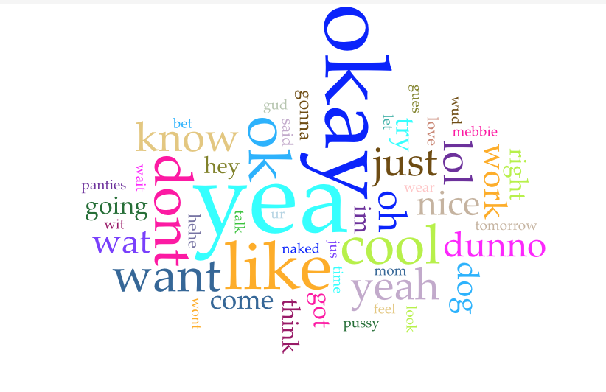

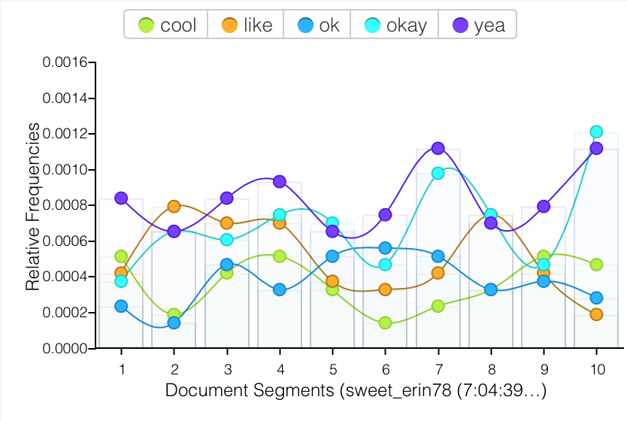

*Note.* Trends Graph of the top five words used most frequently in transcript D created in Voyant Tools.

*Note.* Word Cloud (Cirrus) of 55 high

frequency words from transcript D.

It is interesting to note that most of the five frequency words from all four transcripts are either words of agreement (yea, yes, ok, okay, ya, cool) or words expressing a preference (like, want).

**Discussion**

The digital humanities allow us to work with data visualization tools like Voyant to expand our approach and curiosity about a text. A machine will look at a corpus through an algorithm and then “give” the user-specific data points like word frequency numbers. A close reading of a text, especially transcripts like these can be perceived as emotionally offensive and are viewed from a very different angle by a human reader then by a machine. Can the concept of data, Johanna Drucker wrote about in her 2011 essay *Humanities Approaches to Graphical Display*, be re-thought here “through a humanistic lens and characterized as "capta", taken and constructed” (p. 1)? As mentioned in the Results section, most of the five frequency words from all four transcripts are either words of agreement or words expressing a preference. Voyant’s trends graphs enabled a closer look into the occurrences of these keywords within the analyzed transcripts. The word use of *like* and *want* takes place predominantly in the second and third segments of these chats, while there is a spike of agreement words like *yes*, *okay* and *cool* or variations thereof in the latter parts of the conversation in segments nine and ten. This points toward a conversational strategy on part of the predator by expressing his fantasies and desires early in the chat and trying to reach an agreement on the next steps in their “relationship” towards the end of it while establishing an environment of compliance with their underage victims throughout. Therefore, these findings seem to support the hypothesis that frequently used words in online grooming chats can reveal a predator’s conversational strategy. It should be noted that the word *lol* appears among the top five high-frequency words in half of the analyzed chats. This texting acronym has been used by both parties and indicates more than just the emphasis of a funny situation. It appears that feelings of awkwardness and insecurity are communicated with its use by the minor. The adult on the other hand uses this word to create a young and “hip” personality. Voyant Tools helped sur-face these keywords. “But picturing histories anew will require us to go beyond big-data *algorithmic* analysis and visualization” (Nowviskie, 2014). More research must go into creating safe online spaces for minors as the Canadian Centre for Child Protection (2021) reports a 37% increase in online luring incidents in 2020 compared to the previous five-year average. We need more “agendas of empathy” (Nowviskie, 2014).

**References**

Black, P. J., Wollis, M. A., Woodworth, M., & Hancock, J. T. (2015). A linguistic analysis of

grooming strategies of online child sex offenders: Implications for our understanding of predatory sexual behavior in an increasingly computer-mediated world. *Child abuse & neglect*, 44.

Canadian Centre for Child Protection. (2021). *New Statistics Canada crime data shows victimization of children intensified during pandemic*. Retrieved February 24, 2022, from https://protectchildren.ca/en/press-and-media/news-releases/2021/stats-canada-crime-data-pandemic

Chatcoder. (n.d.). *Data*. https://www.chatcoder.com/data.html

Chiu, M. M., Seigfried-Spellar, K. C., & Ringenberg, T. R. (2018). Exploring detection of contact vs. fantasy online sexual offenders in chats with minors: Statistical discourse

analysis of self-disclosure and emotion words. *Child abuse & neglect*, 81.

De Camp, V. (2006). *Vamale_692005*. Perverted Justice. Retrieved April 9, 2022, from http://www.perverted-justice.com/?archive=vamale_692005

Drucker, J. (2011). *Humanities approaches to graphical display*. DHQ: Digital Humanities Quarterly: Humanities Approaches to Graphical Display. Retrieved February 24, 2022, from http://www.digitalhumanities.org//dhq/vol/5/1/000091/000091.html

Egan, V., Hoskinson, J., & Shewan, D. (2011). *Perverted Justice: A Content Analysis of the Language Used by Offenders Detected Attempting to Solicit Children for Sex*. Antisocial Behavior: Causes, Correlations and Treatments. 20.

Government of Canada. (2021). *Infographic - Online Child Sexual Exploitation*. Retrieved February 24, 2022, from https://www.canada.ca/en/public-safety-canada/campaigns/online-child-sexual-exploitation/infographic-online-child-sexual-exploitation.html

Harvey, D. (2004). *Fleet_Captain_Jaime_Wolfe*. Perverted Justice. Retrieved February 24, 2022, from http://www.perverted-justice.com/index.php?archive=fleet_captain_jaime_wolfe&nocomm=true

Nowviskie, B. (2014). *Digital Humanities in the anthropocene*. Bethany Nowviskie. Retrieved April 11, 2022, from https://nowviskie.org/2014/anthropocene/

Perverted Justice. (n.d.). *Archives*. http://www.perverted-justice.com/index.php?archive=full

Retired Contributor. (2016a). *Nice Guy*. Perverted Justice. Retrieved February 24, 2022, from http://www.perverted-justice.com/?archive=Nice+Guy

Retired Contributor. (2016b). *Louisianamaster1983*. Perverted Justice. Retrieved April 9, 2022, from http://www.perverted-justice.com/?archive=louisianamaster1983

Sinclair, S., & Rockwell, G. (2016). Voyant Tools. [Web Application]. Web.

<http://voyant-tools.org/>.

Westlake, B. G. (2020). The past, present, and future of online child sexual exploitation:

Summarizing the evolution of production, distribution, and detection. *The Palgrave Handbook of International Cybercrime and Cyberdeviance*, 1225–1253. https://doi.org/10.1007/978-3-319-78440-3_52